Weekly Status Report
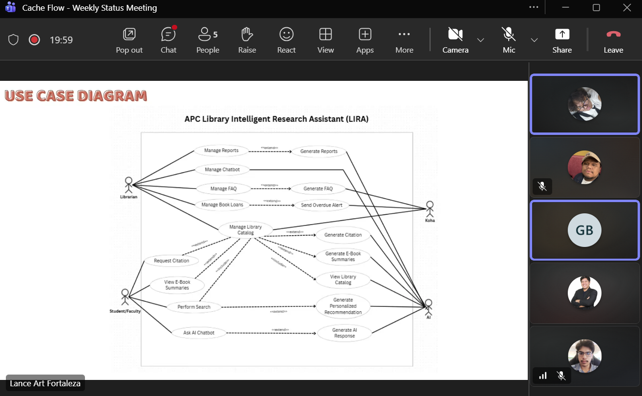
Minutes of Meeting
Date: 08-25-2026
Meeting Called By: Cache Flow
Facilitator: Edward Mandac
Link of the Meeting:

1. Attendees
Gian Ace Buaquiña
Beejay A. Carpio
Lance Art P. Fortaleza
John Carl Gabriel Guzman

2. Agenda
*Comments of the panelist
- Finalize and revise the Use Case Diagram based on panelist comments.
- Align the AI integration boundaries.
- Restructure the Use Case Full Description document so its layout matches the updated diagram sequence.

3. Summary
- Reviewed the panel comments regarding use case diagram.
- Clarified that "Managed Reports" gives the librarian full access (add, edit, update, delete permissions) inside the system
- Re-ordered the process flow of the Use Case Diagram

* Blockers/Obstacle that encounter this week
Need to update all affected documents specifically fixing the Use Case Full Description to add numbered steps and exception conditions required by the panelists.

